Cooking with Doug: St. Patrick’s Day Edition
Irish Soda Bread
Prep: 15 mins
Cook: 50 mins
Total: 1 hr 5 mins
Servings: 20

Ingredients
4 cups all-purpose flour
4 tablespoons white sugar
1 teaspoon baking soda
1 tablespoon baking powder
½ teaspoon salt
½ cup margarine, softened
1 cup buttermilk
1 egg
½ cup butter, melted
½ cup buttermilk
*Can add cup of raisins or cranberries

Directions
1. Preheat oven to 375 degrees. Lightly grease a large baking sheet.
2. In a large bowl, mix together flour, sugar, baking soda, baking powder, salt, and margarine. Stir in 1 cup of buttermilk & egg. Turn dough out onto a lightly floured surface & kneed slightly. Form dough into a round ball & place on a prepared baking sheet. In a small bowl, combine melted butter with ¼ cup buttermilk; brush loaf with this mixture. Use a sharp knife to cut an ‘X’ into the top of the loaf.
3. Bake in preheated oven until a toothpick inserted into the center of loaf comes out clean, 45 to 50 minutes. Check for doneness after 30 minutes. You may continue to brush the loaf with the butter mixture while it bakes.

Source: allrecipes.com

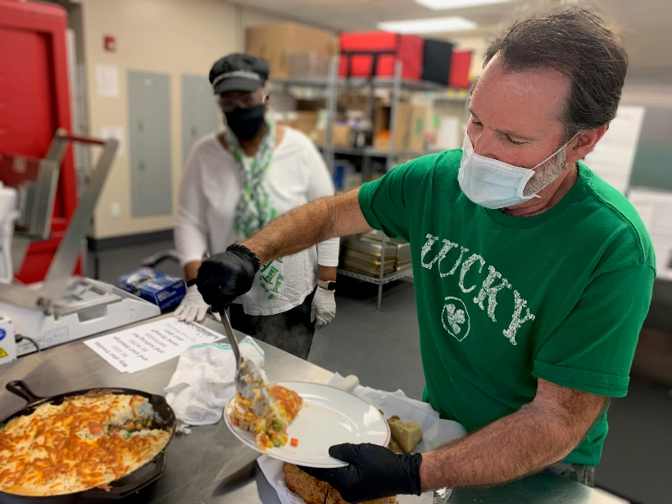
Shepherd’s Pie
Prep: 25 mins
Cook: 1 hr 10 mins
Total: 1 hr 35 mins
Servings: 8

Ingredients
1 tablespoon olive oil
1 tablespoon butter
1 onion, diced
2 pounds lean ground lamb (can sub round beef or pork)
1/3 cup all-purpose flour
Salt & pepper to taste
1 teaspoons minced fresh rosemary
1 teaspoon paprika
1/8 teaspoon ground cinnamon
1 tablespoon ketchup
3 cloves garlic, minced
2 ½ cups water, or as needed
1 (12 oz) package frozen peas & carrots, thawed
2 ½ pounds Yukon Gold potatoes, peeled & halved
1 tablespoon butter

Directions
1. Preheat the oven to 375 degrees.
2. Place olive oil & butter in Dutch oven over medium heat. Stir in onion & ground lamb (or beef/lamb); brown the meat, breaking it up into small crumbles as it cooks, about 10 minutes.
3. Stir in flour (can use cornstarch slurry to sub for flour) until incorporated, then mix in salt, black pepper, rosemary, paprika, cinnamon, ketchup, & garlic; cook & stir until garlic is fragrant, 2 to 3 minutes.
4. Stir in water & scrape up any brown bits from the bottom of the Dutch oven. Reduce heat to medium-low & bring mixture to a simmer; cook & stir until thick, about 5-6 minutes.
5. Remove lamb (or beef/pork) mixture from heat & stir in peas & carrots until combined.
6. Spread meat mixture into the bottom of a 9x13-inch baking dish & set aside.
7. Place potatoes into a large pan of salted water. Bring to a boil, reduce heat to medium, & cook until tender, about 15 minutes. Drain well & return potatoes to pan. *Can sub instant potatoes.*
8. Mash butter, cayenne pepper, cream cheese, and Irish cheese into the potatoes. Mash until combined and potatoes are smooth. Season to taste with salt and black pepper.
9. Whisk together egg yolk and milk in a small bowl; stir into the mashed potato mixture.
10. Top the meat mixture in the baking dish with the mashed potatoes and spread evenly to cover.
11. Bake in the preheated oven until the top is golden brown and sauce is bubbling up around the edges, 25 to 30 minutes.

Source: all recipes.com

Potato Candy
(Sounds weird, we know, but don’t knock it ‘til you try it!)
Prep: 20 mins
Additional: 2 hrs 30 mins
Total: 2 hrs 50 mins
Servings: 24

Ingredients
1 (2 pound) pkg confectioners’ sugar
½ cup leftover mashed potatoes (prepared w/ butter, salt, & milk)
1 ½ tablespoons butter
1 tablespoon vanilla extract
3 tablespoons confectioners’ sugar, or as needed
1 (18 oz) jar creamy peanut butter

Directions
1. Combine confectioners' sugar, mashed potatoes, butter, and vanilla extract in a large bowl until a thick dough forms. Refrigerate dough until chilled, about 30 minutes. Stir extra confectioners' sugar into dough if too moist.
2. Spread a large sheet of waxed paper on the counter. Sprinkle with confectioners' sugar.
3. Dust rolling pin with confectioners' sugar. Roll chilled dough on prepared waxed paper into a 1/4-inch thick rectangle.
4. Spoon peanut butter into a microwave-safe bowl. Heat in microwave on High until slightly softened, 20 to 30 seconds.
5. Spread softened peanut butter onto dough.
6. Roll dough, starting from long end, into a jelly roll shape.
7. Wrap the roll in waxed paper and refrigerate until firm, about 2 hours. Slice into 1/4-inch slices.

*Note: If you do not have left over mashed potatoes, use instant OR throw potato in microwave for 5 mins, cool & add butter & a little salt (NO pepper).
Source: allrecipes.com

Thank you, Doug & Cathy!
Come join Doug next time on Tuesday, April 6th at 11:00AM. We will be gathering in person, on a first come first serve basis. To reserve your spot, please call us at (910) 754-7427 within 48 hours of the program!
Monetary contributions to cover cost of food is greatly appreciated, so we may continue this fun program with our one-of-a-kind Cook

